

• • • •
• • • •
• • • •
NATIONAL
CLOSED
CHAMPIONSHIPS
2026
Saturday 21st & Sunday 22nd March 2026
National Basketball Arena, Tallaght, Dublin 24
Irish Ranking Tournament – Class 1

Supported by South Dublin County Council and The Louis Fitzgerald Hotel

CHAIRPERSON'S MESSAGE
FOREWORD
On behalf of the Board of Table Tennis Ireland, I am delighted to welcome players, officials, volunteers and supporters to the Table Tennis Ireland National Championships.
This annual event represents the pinnacle of domestic competition and the opportunity to compete for the honour of becoming a National Champion. It reflects the dedication shown throughout the season by players, coaches and clubs, and highlights the strength of our table tennis community.
My thanks to the organisers, staff, referees, umpires and volunteers whose work ensures the smooth running of the event, and to our sponsors for their valued support. I wish all competitors every success and hope the weekend provides excellent competition.
Arnold Morgan
Chair, Table Tennis Ireland
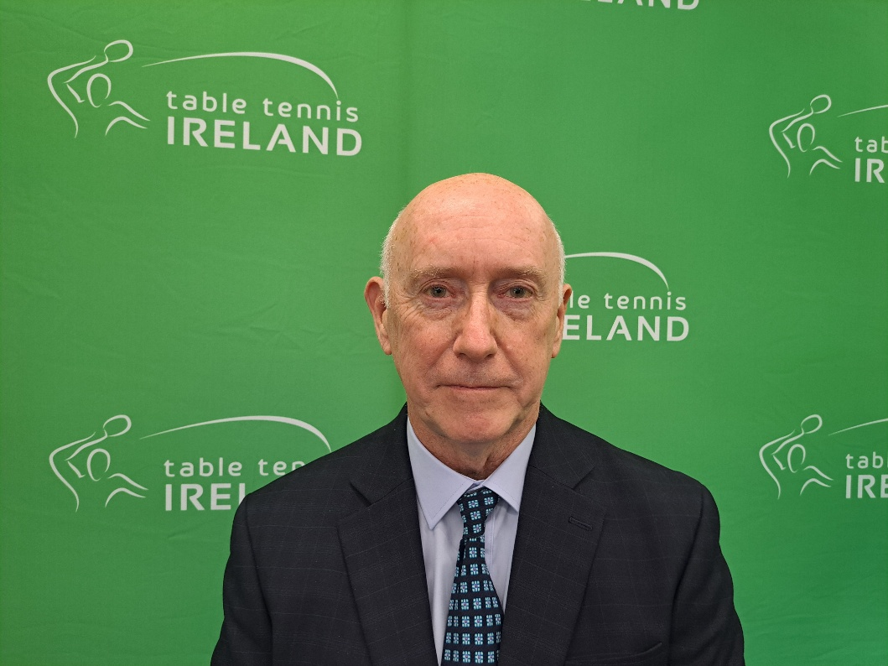

PRESIDENT'S MESSAGE

Compete, enjoy, learn, improve, reflect and travel well at the Nationals!
Above all, respect everyone, exercise fair play, make friends and seek to enhance the Community of TTI … and, on your way home, be sure to honestly (warts & all) analyse, review and give feedback, as you are all part of the present AND future of Table Tennis.
Best wishes — you are all Winners!
Alan Strong MBE
President, Table Tennis Ireland
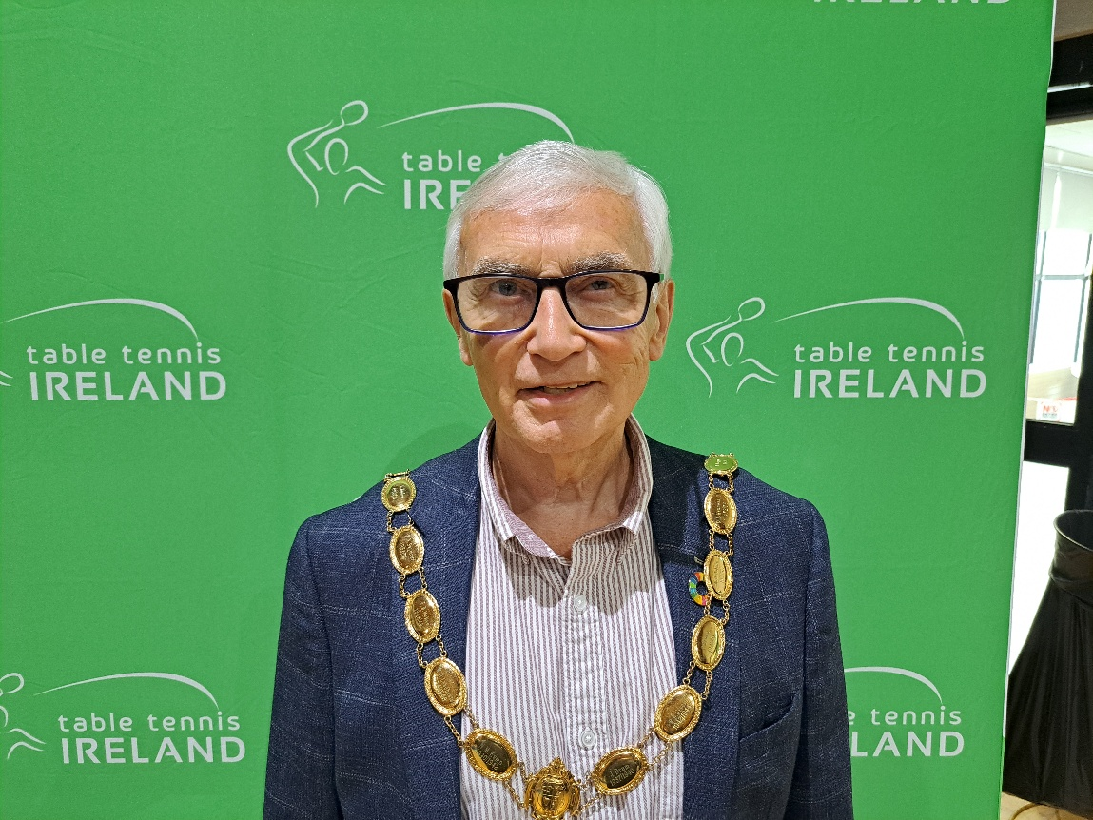
National Closed Championships 2026 — Timetable
National Basketball Arena, 8 Tymon Lane, Tallaght, Dublin 24
Irish Ranking Tournament – Class 1
Saturday 21st March
U21 Men & Women | 08:45
Restricted | 09:00
Men's & Women's Singles | 13:00
Para | 16:00
Men's & Women's Doubles | 17:00

Sunday 22nd March
U19 Boys & U19 Girls | 08:45
U15 Boys & U15 Girls | 08:45
U11 Boys & U11 Girls | 10:00
U17 Boys & U17 Girls | 13:00
U13 Boys & U13 Girls | 13:00

Draw for Saturday
Mens Under 21s

GROUP | A |  | GROUP B |  |  | GROUP C
A1 | Alex Lo |  | B1 | Aedan McGivern |  | C1 | Toby Caldwell
A2 | Rory Fallon |  | B2 | Diarmaid Byrne |  | C2 | Daniel Patterson
A3 | Ben Dickson |  | B3 | Ronan Geary |  | C3 | Matthew Geary
A4 |  |  | B4 |  |  | C4 | Andrew Low
GROUP D | F |  | GROUP E |  |  | GROUP F | D
F1 | Christopher Allsop |  | E1 | Ryan Li |  | D1 | Adam Faulkner
F2 | Peter Cao |  | E2 | Matthew Bailie |  | D2 | Adam Hedderly
F3 | Rex Montag |  | E3 | Aaditya Singh |  | D3 | Noah Brennan
F4 | Sean Buckley |  | E4 | Jack O'Connell |  | D4 | Erdem Mehmed
GROUP G |  |  | GROUP H |  |  | GROUP J
G1 | He ming Duan |  | E1 | Tom Irwin |  | F1 | Jack Bailie
G2 | Aaron Mellows |  | E2 | caleb jiang |  | F2 | Kuang Ze Vincent Ni
G3 | Junior Close |  | E3 | Conor Eyre |  | F3 | Harrison Yuen
G4 | Conor Sheehan |  | E4 | Martin Burke |  | F4 | Conor Walsh

Womens Under 21

GROUP A |  | GROUP B
Anjali Singh |  | Lily Parke
Rebecca Scott |  | Grace Looney
Niamh Mason |  | Caoimhe Deane
 |  | Matilda Crozier

Restricted Singles

Group A |  | GROUP B |  |  | GROUP C
A1 | Armand Bratulescu | B1 | Philip Shaw |  | C1 | sylwester hajdul
A2 | David Noonan | B2 | John Smith |  | C2 | Manel de Riquer
A3 | Aaron Keogh | B3 | Slobodan Horvat |  | C3 | Ege Oguzman
A4 | Alexey Reutov | B4 | Bernie Franklin |  | C4 | Allan Rennu
GROUP | F | GROUP E |  |  | GROUP | D
F1 | Myo Chit Ko | E1 | Pat McCloughan |  | D1 | Tibor Pofók
F2 | Fergal O'Hagan | E2 | Chris Kearney |  | D2 | Vladimir Brzak
F3 | Jude Sheldon | E3 | Daniel Irwin |  | D3 | Sylwia Idec
F4 | Pau de Riquer | E4 | Miranda Parra Escalona |  | D4 | Sean Buckley
GROUP G |  | GROUP H
G1 | Chris Cowan | E1 | Hansen Gonzalez
G2 | David Taylor | E2 | Stuart Grannell
G3 | Preston Walton | E3 | Albert Radkin
G4 | Deon Binu | E4 | Roman Sorici

Womens Singles

GROUP | A |  |  | GROUP | B |  | GROUP | C
A1 | Mia O'Rahilly Egan |  |  | B1 | Anjali Singh |  | C1 | Claire Heller
A2 | Lily Parke |  |  | B2 | Alessandra Fadda |  | C2 | Niamh Mason
A3 | Samanta Pusinskaite |  |  | B3 | Caoimhe Deane |  | C3 | Nuria Goldston
A4 | Sylwia Idec |  |  | B4 | Bernie Franklin |  | C4 | Rebecca Scott
A5 | Sophie Warwick |  |  | B5 | Caitlyn Warwick |  | C5 | Matilda Crozier
 |  |  |  |  |  |  | GROUP F | D
 |  |  |  |  |  |  | D1 | Grace Looney
 |  |  |  |  |  |  | D2 | Sabina Devereux
 |  |  |  |  |  |  | D3 | Chui Lin KWOK
 |  |  |  |  |  |  | D4 | Miranda Parra Escalona
 |  |  |  |  |  |  | D5 | Flora Redahan
Mens Singles

GROUP | A |  |  | GROUP | B |  |  |  | GROUP | C
A1 | Christopher Allsop |  |  | B1 | Toby Caldwell |  |  |  | C1 | Colin Judge
A2 | Albert Radkin |  |  | B2 | Daniel Patterson |  |  |  | C2 | caleb jiang
A3 | Rory Fallon |  |  | B3 | Daniel Daly |  |  |  | C3 | Tibor Pofók
A4 |  |  |  | B4 | Andrew Low |  |  |  | C4 | Martin Burke
GROUP D | F |  |  | GROUP E |  |  |  |  | GROUP F | D
F1 | Tom Irwin |  |  | E1 | Joe Sheard |  |  |  | D1 | Kuang Ze Vincent Ni
F2 | Hansen Gonzalez |  |  | E2 | Conor Sheehan |  |  |  | D2 | Stuart Grannell
F3 | Jude Sheldon |  |  | E3 | Jack Bailie |  |  |  | D3 | Rex Montag
F4 |  |  |  | E4 | Magnus Redahan |  |  |  | D4 | Sean Chen
GROUP G |  |  |  | GROUP H |  |  |  |  | GROUP J
G1 | Aedan McGivern |  |  | E1 | Dillon Byrne |  |  |  | F1 | Clifford Tan
G2 | Seán Geoghegan |  |  | E2 | Pat McCloughan |  |  |  | F2 | Aaron Mellows
G3 | Ronan Geary |  |  | E3 | Fergal O'Hagan |  |  |  | F3 | Jack O'Connell
G4 | Chris Kearney |  |  | E4 | Peter Cao |  |  |  | F4 | Slobodan Horvat
GROUP | M |  |  | GROUP | L |  |  |  | GROUP | K
M1 | Armand Bratulescu |  |  | L1 | Junior Close |  |  |  | K1 | Ning Na
M2 | David Taylor |  |  | L2 | Karsten Close |  |  |  | K2 | WAI TAT SUM
M3 | Conor Walsh |  |  | L3 | Ben Dickson |  |  |  | K3 | Harrison Yuen
M4 | Matthew Bailie |  |  | L4 | John Smith |  |  |  | K4 | Ethan Licayan
GROUP | N |  |  | GROUP | O |  |  |  | GROUP | P
N1 | Paddy Vaughan |  |  | O1 | Cillian Kirby |  |  |  | P1 | Sam Logue
N2 | Adam Hedderly |  |  | O2 | Vladimir Brzak |  |  |  | P2 | Anthony Redmond
N3 | David Noonan |  |  | O3 | Diarmaid Byrne |  |  |  | P3 | Ryan Li
N4 | Noah Brennan |  |  | O4 | Preston Walton |  |  |  | P4 | Aaron Keogh
 |  |  |  | GROUP | R |  |  |  | GROUP | Q
 |  |  |  | R1 | Daniel Irwin |  |  |  | Q1 | Sam Brennan
 |  |  |  | R2 | sylwester hajdul |  |  |  | Q2 | He ming Duan
 |  |  |  | R3 | Chris Cowan |  |  |  | Q3 | Chetan Rai
 |  |  |  | R4 | Conor Eyre |  |  |  | Q4 | Evaldas Pusinskas

Para – Awaiting groups to be added
Doubles – cancelled.

Draw for Sunday
 | Boy's U19
GROUP A |  |  | GROUP B |  |  | GROUP C
A1 | Aedan McGivern |  | B1 | Aaditya Singh |  | C1 | Christopher Allsop
A2 | Harrison Yuen |  | B2 | Rory Fallon |  | C2 | Sam Brennan
A3 | Rex Montag |  | B3 | Jude Sheldon |  | C3 | Jack O'Connell
A4 | Ryan Li |  | B4 | Shao Jun Daniel Chen |  | C4 | Oisín Ó hÓgáin
GROUP | D |  | GROUP E |  |  | GROUP D | F
D1 | Kuang Ze Vincent Ni |  | E1 | Jack Bailie |  | F1 | Clifford Tan
D2 | Kevin O callaghan |  | E2 | Conor Sheehan |  | F2 | Daniel Patterson
D3 | Noah Brennan |  | E3 | Luke Ferris |  | F3 | Sean Buckley
D4 | Ben Dickson |  | E4 | Ronan Geary |  | F4 | Albert Radkin
GROUP G
G1 | Toby Caldwell
G2 | Belal Abdelaal
G3 | Isaac Gough
G4 | Conor Eyre

Girl's U19
GROUP A |  | GROUP B
Anjali Singh |  | Lily Parke
Niamh Mason |  | Grace Looney
Rebecca Scott |  | Caoimhe Deane
Melissa Johnston |  | Miranda Parra Escalona

 | Boys U17
GROUP A |  | GROUP B |  | GROUP C
A1 | He ming Duan | B1 | Christopher Allsop | C1 | Aaditya Singh
A2 | Luke Ferris | B2 | Haoyun Gong | C2 | Sean Buckley
A3 | Kevin O callaghan | B3 | Rory Fallon | C3 | Erdem Mehmed
A4 |  | B4 | Sean Chen | C4 | Ross O'Toole
GROUP D | F | GROUP E |  | GROUP F
F1 | Ryan Li | E1 | Karsten Close | D1 | Clifford Tan
F2 | Rex Montag | E2 | Matthew Bailie | D2 | Noah Brennan
F3 | Gabriel Corzo | E3 | Adam Barron | D3 | Harrison Yuen
F4 | Darragh Hennessy | E4 | Conor Leonard | D4 | Billy FitzGerald
GROUP G |  | GROUP H |  | GROUP J
G1 | Toby Caldwell | E1 | caleb jiang | F1 | Adam Hedderly
G2 | Andrew Low | E2 | Peter Cao | F2 | Belal Abdelaal
G3 | Alon Romem | E3 | Conor Eyre | F3 | Oisín Ó hÓgáin
G4 | Curtis Rutten | E4 | Isaac Gough | F4 | Pau de Riquer

Girl’s U17

GROUP A |  | GROUP B |  | GROUP C
A1 | Nuria Goldston | B1 | Lea Gal | C1 | Jane Wilson
A2 | Evelyn Fan | B2 | Polly Smith | C2 | Miranda Parra Escalona
A3 | Rachel Johnston | B3 | Titanilla Kozak | C3 | Matilda Crozier
A4 |  | B4 |  | C4

 | Boy's U15
GROUP A |  |  | GROUP B |  |  | GROUP C
A1 | Adam Hedderly |  | B1 | He ming Duan |  | C1 | Karsten Close
A2 | ZIQI WANG |  | B2 | Adam Barron |  | C2 | Shaurya Verma
A3 | Gabriel Borucki |  | B3 | Mason Shallow |  | C3 | Toby Canning
A4 |  |  | B4 | Jackson Kelly |  | C4 | Xuefu Zeng
 |  |  | GROUP E
GROUP F | D |  | E1 | Daniel Daly |  | GROUP D | F
D1 | caleb jiang |  | E2 | Tobias Gal |  | F1 | Peter Cao
D2 | Alon Romem |  | E3 | Patrick Hogg |  | F2 | Reece Maguire
D3 | Jacob Steele |  | E4 | George Barber |  | F3 | Evan O Flaherty
D4 | Ling Qi kong |  |  |  |  | F4 | Lucas Toal
GROUP G |  |  | GROUP H |  |  | GROUP J
G1 | Andrew Low |  | E1 | Deon Binu |  | F1 | Erdem Mehmed
G2 | Gabriel Corzo |  | E2 | Curtis Rutten |  | F2 | Pau de Riquer
G3 | Darragh Hennessy |  | E3 | Max Bellew |  | F3 | Conor Leonard
G4 | Billy FitzGerald |  | E4 | Vihaan ravikumar |  | F4 | Sean Chen
GROUP | K |  | GROUP | L
K1 | Haoyun Gong |  | L1 | Matthew Bailie
K2 | Matthew Geary |  | L2 | Jayden Yan Theunissen
K3 | Ross O'Toole |  | L3 | Yuxiang Wang
K4 | Max Liddy |  | L4 | Max Bellew

 | Girl's U15
GROUP A |  | GROUP B |  | GROUP C
A1 | Samanta Pusinskaite | B1 | Nuria Goldston | C1 | Lea Gal
A2 | Evelyn Fan | B2 | Naysa Kohli | C2 | Anna Matveyeva
A3 | Caitlyn Warwick | B3 | Rosie Agnew | C3 | Emma Ocallaghan
A4 |  | B4 | Victoria Sawecka | C4 | Titanilla Kozak
GROUP F | D
D1 | Jane Wilson
D2 | Polly Smith
D3 | Victoria Junyszek
D4 | Matilda Crozier

 | Boy's U13
GROUP A |  | GROUP B |  | GROUP C
A1 | Daniel Daly | B1 | Jamie Yan Theunissen | C1 | ENOCH HUANG
A2 | Shan Sheridan | B2 | Gabriel Borucki | C2 | PJ Rooney
A3 | Tom Drechsler | B3 | Evan O Flaherty | C3 | Shaurya Verma
A4 | Noah O'Connor | B4 | Noah O'Connor | C4 | Jackson Kelly
GROUP | D | GROUP E |  | GROUP D | F
D1 | Deon Binu | E1 | Jayden Yan Theunissen | F1 | Tobias Gal
D2 | ZIQI WANG | E2 | Rudra Ramji | F2 | Mason Shallow
D3 | Xuefu Zeng | E3 | Will Agnew | F3 | Max Liddy
D4 | Vihaan ravikumar | E4 | Sam Liddy | F4 | Bobby Toole
GROUP G
G1 | Matthew Geary
G2 | Reece Maguire
G3 | Max Bellew
G4 | Lucas Toal

 | Girl's U13
GROUP A |  | GROUP B |  | GROUP C
A1 | Samanta Pusinskaite | B1 | Victoria Sawecka | C1 | Anna Matveyeva
A2 | Rosie Agnew | B2 | ZILIN WANG | C2 | Victoria Junyszek
A3 | Freya Sheridan | B3 | Leyla Dervis | C3 | Arya Ramji
A4 |  | B4 | Sophie Warwick | C4 | Beatrice Glencross

 | Boy's U11
GROUP A |  | GROUP B |  | GROUP C
A1 | Jamie Yan Theunissen | B1 | ENOCH HUANG | C1 | Rudra Ramji
A2 | Shan Sheridan | B2 | Will Agnew | C2 | PJ Rooney
A3 | Sam Liddy | B3 | Tom Drechsler | C3 | Rafael Drugg
A4 |  | B4 | Liam Schoebel | C4 | Matthew Drechsler

Girl’s U13
Name | Club Name
Victoria Sawecka | Leeside TTC
ZILIN WANG | Loop Table Tennis Club
Arya Ramji | Table Tennis Valley Club
Leyla Dervis | Balbriggan Table Tennis Club
Veronika Matsveyeva | Dublin

Umpire Ambassador Club Visit Programme
Table Tennis Ireland is launching a new Umpire Ambassador Club Visit Programme, and we would love your club to be involved.
These free, practical visits are designed to help your players, coaches, and volunteers feel more confident about rules, serving technique, and match management — creating a better playing experience for everyone.
Why we’re doing this
Clubs told us they want:
- Clearer rules education
- Better serving technique understanding
- Less confusion during matches
- More confident volunteers
This programme responds directly to these needs and aligns with TTI’s 2026–2028 Technical Officials Development Plan to rebuild the umpiring workforce and enhance competition quality.
What your club gets
- Rule & Match Education
Short, practical demonstrations of common rule misunderstandings and match scenarios.
- Serving Workshop
Correct serving technique explained and demonstrated — the biggest area of match confusion.
- Player & Coach Q&A
A safe, supportive space to ask questions.
- Information on Development Pathways
Information for any player, parent or volunteer interested in becoming an umpire — including new pathways and mentoring support.
What we ask from the club
- Provide 45–60 minutes during a training session
- A table available for demos
- Encourage coaches and players to attend
- Optional: identify members who may be interested in officiating
How to book Email info@tabletennisireland.ie or complete the online form:https://forms.office.com/Pages/ResponsePage.aspx?id=MFqZ1hxEeUeYP4Lrm06O2U0RZczK175LijOt4IfVL4dUODQ4RE8wSExLTFZPR0FYSVdOS0ZLQVZCVy4u
Upcoming Level Two Coaching Course
Table Tennis Ireland is pleased to announce that our next Level 2 Coaching Course is now confirmed. Full course details are outlined below.

This will be our first Level 2 course delivered since receiving official certification from Sport Ireland.
On completion, participants will receive a Sport Ireland–issued certificate, recognising the qualification under the national coaching framework.

Venue : Fingal Liam Rodgers Centre, Feltrim Road, Swords, Co. Dublin

Course Dates
- Day 1: Saturday, 16th May
- Day 2: Sunday, 17th May
- Day 3: Saturday, 22nd August
Course Fee: €315
Entry Requirements
- Be 18 years or older
- Hold a Level 1 coaching qualification
- Have a minimum of 2 years’ coaching experience at Level 1
- Hold valid Garda Vetting / Access NI
- Hold a Safeguarding 1 certificate
- Have a valid First Aid certificate (Sports First Aid preferred)
Please note:
The registration link will be issued privately to individuals who meet the essential eligibility criteria, particularly the coaching experience requirement. If you are interested in signing up contact molly.doyle@tabletennisireland.ie.
Questions?
For further information or assistance, contact info@tabletennisireland.ie

