

**Table Tennis Ireland Validator Process**

**Validation of documents identity & address validation is required by Garda National Vetting Bureau (GNVB).** The validation required by GNVB refers to the process by which an individual certifies that a copy of a document is a true and accurate reproduction of the original.

The person validating must have seen the **original document** and must state that the copy document is the same as the original which was presented at the time of validation.

To ensure a thorough validation process, organisations must validate identity documents in person, and maintain an auditable process in which:

1. The validator must physically see the documents to confirm the vetting subject matches the documents.
2. The following details must be recorded in the designated section of the NVB1 form:

* Document type and reference number (e.g. Passport number)
* The date of validation must be recorded.
* The validator’s name, position, and organisation must be clearly recorded and their name printed and signed.
* This must be filled in BLOCK CAPITALS and wet signature only.

**Who can be a validator:**

Clubs can verify vetting for their members of their club. The following club officers can verify documents (are validators):

Club Chair, Secretary, Treasurer and Child Safeguarding Officer.

**Validating Applicants Over 18**

The proof of identity document must be deemed acceptable based on the criteria below:

* The document being relied upon must be current and not expired.
* The identity document must be a valid form of identification (as per the Identity table below).
* The photograph on the original document must match the vetting subject and must be of high quality and clear.
* The name on the document must match the name provided on the NVB1 Form.
* The date of birth on the document must match the date provided on the NVB1 Form.
* The copy of the document produced must also be clear and legible for audit purposes.

**What Next?**

The **individual being vetted** emails a photo/scan of the completed form (both sides) and also the ID and proof of address documents to info@tabletennisireland.com. T**he individual being vetted** must also post the original completed form (both sides) to Garda Vetting, Table Tennis Ireland, Irish Sport HQ, Sport Ireland Campus, Blanchardstown D15DY6. **It is not the responsibility of the validator to email or post the documents, this is to reduce risk of retention of members soft copy documents.**

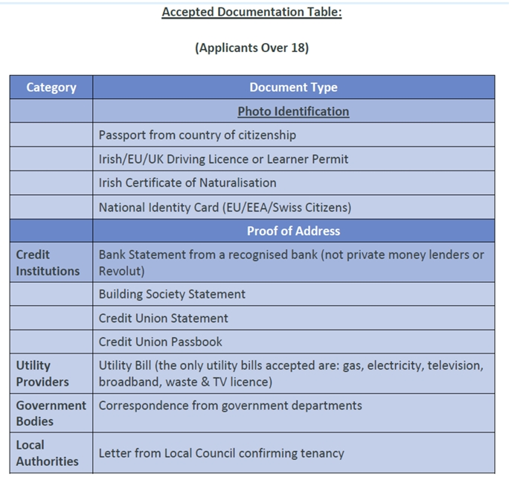

**Validating Applicants Under 18**

In circumstances where an applicant under the age of 18, does not have documentation outlined in the accepted documentation table, the following will also be accepted.

Two documents must be submitted, one to support identification and one to support proof of address.

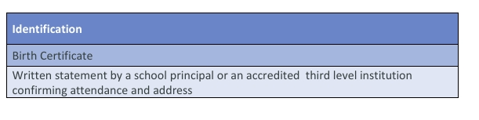

**Retention and Storage of Documents**.

The GNVB requires the retention of identity documents and consent forms.

Purpose of Retention:

* Prevent, detect and investigate offences under the Act.
* Enable the GNVB to perform its functions. Ensure compliance with the vetting process.
* Assist in investigating breaches.

Who will retain these documents?

* Table Tennis Ireland will safely store the documents both hard and soft copies. Once the individual

Data to be Retained:

* Retain original NVB1 form for the initial 6 month at a minimum.
* After the initial 6-month period a soft copy of the NVB1 form will suffice.
* Soft copies of proof of identity and proof of address documents. Retention periods required by Garda National Vetting Bureau (other oversight or government bodies may require you to retain documents longer)
* Active Individuals: Data retained for duration of engagement.
* Inactive Individuals: Data destroyed within 12 months of departure.