The Jimmy O’Hara Memorial Cup
Open Singles and Consolation

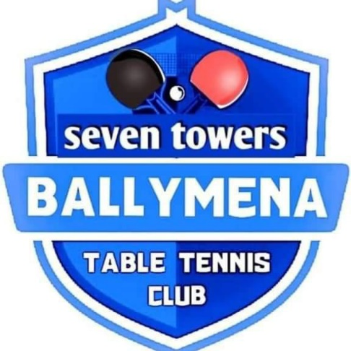

Saturday 4th May 2024

Hosted by Ballymena TT Club
in
Ballymena Academy Gym
89 Galgorm Road, Ballymena BT42 1AJ

Many of you will have known Jimmy O’Hara who sadly died last year at the age of 95. Jimmy played for Ireland in the 1940s and 1950s and in his later years he represented our club with distinction as both player and Club President. Jimmy was the welcoming face at our club with the friendly handshake for all visitors. He was a wonderful ambassador for table tennis – a fact awknowledged by Table Tennis Ireland in 2013 when they awarded him a glass placque for his services to table tennis. But most of all he was a faithful friend who is sadly missed at our club.

We aim to run this tournament each year to benefit local Charities with all proceeds from this, the inaugural event, going to help those suffering from Motor Neurone Disease.

Entrants name:
Email:
Mobile:
Closing date for entries: Wednesday 1st May 2024
Entry Fee: £10 payable on the day.
Entries/queries sent to n5mcb@btinternet.com

Event Schedule
Registration from 10.30am
Start: 11am
Group stage: 11am – 1.30pm
Open Knock Out: 1.30pm – 4pm
Consolation KO: starts 1.30pm
Presentation 4.15pm

Entrance to the Hall is at the side of the building - take first right along main entrance and park at the hockey pitches. The Hall entrance is to your left.

Regulations and Information
- A condition of entry to each event is that players agree to abide by TTU’s Code of Conduct which can be accessed on TTU’s website https://www.tabletennisulster.com/code-of-conduct/

- Participants will be organised into groups initially, and after the format will be a knockout tournament with the top 2 players advancing into the top half of the Division and the bottom 2 moving to the lower half of the Division. Matches will be the best of 5 games unless otherwise specified by the event organiser.

- The final order in a group shall be determined as per ITTF regulation 3.7.5 for group competitions except that where a player concedes a match, he/she shall receive -3 group point

- All players will be expected to umpire when required.

- All players must report to the control table on arrival and must not leave the venue while still in the competition without first obtaining permission from the Referee.

- The tournament organiser reserves the right to alter the format of the draw, cancel any category and to restrict admission to the tournament venue. If a category is over-subscribed, then entries will be treated on a last in–first out basis.

- Event Entry Restrictions: All players must provide their club name as a condition of entry and should be affiliated to the ITTA.

- All disputes will be dealt with by the tournament organiser and/or TTU’s Events Committee whose decision will be final.

1928-2023

