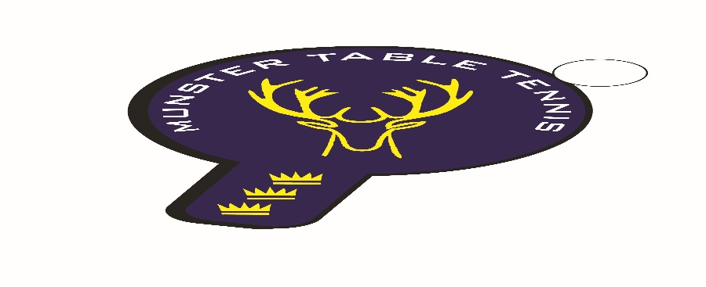
Munster Open 2023
Friday 27/Saturday 28/Sunday 29 January 2023
Saile Sports & Community Centre, Cappagh, Kinsale Co Cork
Eircode: P17WD21
(Irish Ranking Tournament – Class 3)
Referee: Adrian Brown
Assistant to the Referee: Niall O’Flaherty
Note: Live streaming of matches will be in operation as per Tournament Regulations – see below at **
Provisional Schedule of Events & Start Times*
Friday 27th |  | Saturday 28th |  | Sunday 29th
Men’s Singles Group Stage | 1800 | U/15 Boys & Girls | 0830 | U/19 Boys & Girls | 0900
 |  | U/11 Boys & Girls | 0900 | U/13 Boys & Girls | 0900
 |  | U/21 Boys & Girls | 1100 | U/17 Boys & Girls | 1300
 |  | Para Open | 1100 | Veterans | 1300
 |  | Men’s & Women’s Singles | 1400
 |  | Restricted Singles | 1630

* Due to the uncertain nature of entries this season in national ranking tournaments the timetable and categories above are subject to change following receipt of entries. Please watch Table Tennis Ireland website for updates – www.tabletennisireland.ie

Entries via TTI website with JustGo.com
Closing Date: 5pm, 17 January 2023
ENTRY FEES (€)
 | M/W S | Vet | U/21 | Rest. | Para | U/ 11 | U/13 | U/15 |  | U/17 | U/19
Fee  (Senior) | 25 | 20 | 25 | 20 | 20
Fee (Junior) | 15 | - | 15 | 15 | 15 | 10 | 15 | 15 | 15 |  |  | 15

PLUS €5 per player Administration Fee
Format of Events: (Subject to sufficient entry numbers)

Senior singles events:
Groups to knockout (top two in each group advance to knockout). Top seeds in Men’s singles (up to eight seeds) and Ladies’ singles (up to four seeds) may be seeded directly into Knockout stage.

Para/Junior events (U/19, U/17, U/15, U/13, U/11):
First round groups, top two advancing to knockout, remainder to Plate event. Where possible, subject to entry numbers, normal format of groups into groups into KO may apply in some events. Playoffs will take place where possible. Depending on entry numbers, up to top four seeds may receive a bye to KO/2nd Round stage (at discretion of tournament referee).

Restricted Singles – Exclusions apply to Ireland Ranked Top 20 Men and Top 10 Women, or equivalent, at the discretion of the Referee.

Event Categories
Table Tennis Ireland, the Management Committee and the Munster Branch ask for the cooperation of all our clubs and entrants with the attempts to resume competitive domestic activity. Please note that we expect to have a limited number of official Umpires at the event, and players must be available to Umpire per the regulations.
Event start times and check in times will be posted on the TTI Website. Please note that there will also be limitations on arrival times. Players will not be permitted to be in the hall in advance of their own event and should not arrive at the venue ahead of the times stated on the TTI Website.
Groups/times will be posted on the website two days before the tournament.
All players and coaches are advised to check the Table Tennis Ireland website to confirm that all players are entered into the appropriate events.
3 Star Plastic Orange Balls will be used at this event.

Tournament Regulations
- No late entries will be accepted (as per Table Tennis Ireland policy).
- No refunds will be paid out after entries are entered into the draw format.
- Players may not enter two events starting at the same time. Players may enter up to 4 singles events. For age restricted events players may only enter their own age group and their next oldest eligible age group, e.g. U/11 & U/13; U/13 & U/15; U/15 & U/17; U/17 & U/19, U/19 & U21. Maximum entry numbers may apply to different events. In the event of numbers being capped, the general rule of last in=first out will be applied, however, if necessary, certain events may also have entries restricted or rejected on the basis of ranking.
- Date of Birth required for all age-restricted events. U/11 – on or after 01 January 2012. U/13 – on or after 01 January 2010. U/15 – on or after 01 January 2008. U/17 – on or after 01 January 2006. U/19 – on or after 01 January 2004. U/21 – on or after 01 January 2002. Veterans – 39 years and over on 01 January 2022.
- No refunds for players who enter events for which they are not eligible: please check your entry form carefully.
- All matches will be played according to the Rules and Regulations of Table Tennis Ireland and the I.T.T.F.
- Competitors must be affiliated to Table Tennis Ireland. An affiliation check will be carried out by Table Tennis Ireland prior to the event.
- Players will be scratched if not present and ready to play when called upon. Check in time is 30 minutes before the start of a player’s first event.
- All competitors will be required to Umpire.
- The draw will be seeded in all main events. Byes may be allocated in Senior Singles and in U-18 events as per Table Tennis Ireland regulations.
- Matches will be “Best-of-5” (except early round Plate matches: “Best-of-3”)
- Group standings as per I.T.T.F. Regulation 3.7.5 for group competition.
- The decision of the Referee will be final on points of law and in all cases of dispute. The decision of the Umpire will be final on points of fact.
- Due to the revised format, time between playing rounds will be condensed, and players should expect to play rounds in quick succession to each other.
- No coaching or time outs allowed for U/11 event. Under-13 designated Coach to be named at Check-in.
- In line with the TTI Data Protection Policy, which covers the use of photographic and video recording equipment at TTI events, permission for the use of such equipment must be sought from the Referee or Organising Committee. **By entering this tournament, all participants accept that photographs or other recorded images (including live streaming), taken on behalf of TTI, may be used in connection with the promotion of TTI events and activities, except in the case of underage players where consent may be withheld. Withdrawal of consent in the case of underage players must be requested in advance to TTI by the participant, their parent / guardian or coach.
- Doping control tests may take place, more information on doping available on our website: https://tabletennisireland.ie/anti-doping/.
- Table Tennis Ireland including all its Branches, Leagues, Committees and others who are affiliated to Table Tennis Ireland reserves the right to cancel, postpone, discontinue or abandon any event or tournament at any time and for any reason whatsoever (hereinafter “an occurrence”). Where such an occurrence arises, the liability of Table Tennis Ireland shall be limited to a maximum of a refund of the entrance fees paid by the entrant. Table Tennis Ireland does not accept responsibility or liability for any associated and/or consequential losses (including, but not limited to travel or accommodation expenses), whether monetary or otherwise, incurred by the entrant. Table Tennis Ireland does not accept responsibility or liability in respect of any costs, expenses or other losses incurred by spectators, officials, coaches, members of the media or other attendees of any event or tournament.
- Acceptance of these Regulations is itself a condition of entry.

Prize money will be awarded in the Men’s & Women’s Singles, Restricted Singles, U/21 Boys & Girls and Veterans. Trophies or medals will be awarded in all other events.
HOTELS and B&B information
Kinsale
Blue Haven Hotel, town centre: 021 470600
Trident Hotel, town centre: 021 4779300
Actons Hotel, town centre: 021 4779900
Kinsale Hotel & Spa: 5 mins from town centre: 021 4706000
Giles Norman Townhouse, town centre: 021 4774373
Blind Gate House, town centre: 021 4777858
Danabel B & B, town centre: 021 4774087
The K Kinsale Guest House, 10 mins from town centre: 087 1548153
Nearby locations
Innishannon House Hotel, 16 mins from Kinsale: 021 4775121
Cork Airport Hotel, 20 mins from Kinsale:
Cork International Hotel, 20 mins from Kinsale
Carrigaline Court Hotel, 22 mins from Kinsale: 021 4852100
Munster Arms Hotel, Bandon, 24 mins from Kinsale: 023 8841562

