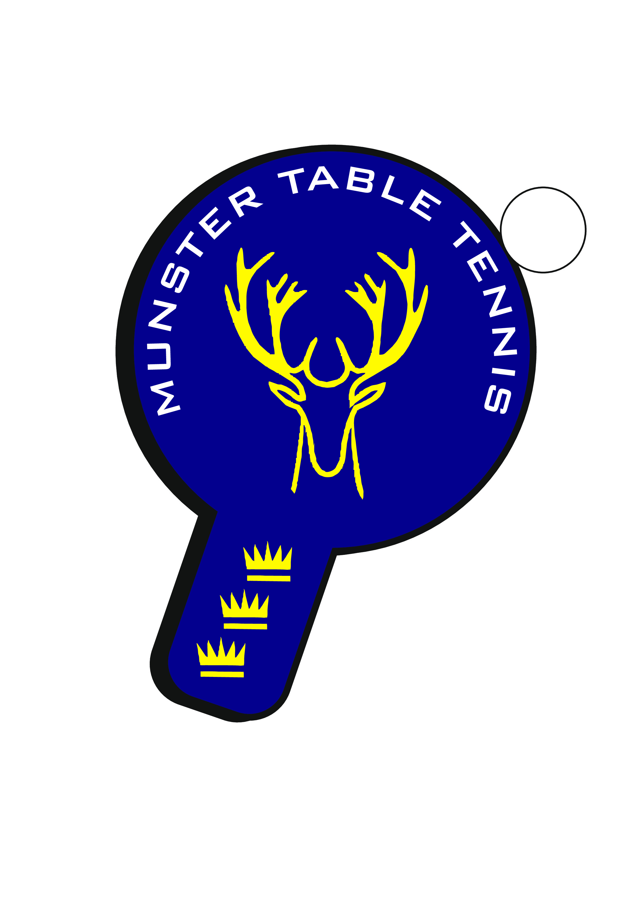
Munster Open 2022
Saturday 21/Sunday 22 May 2022
Saile Sports & Community Centre, Cappagh, Kinsale Co Cork
Eircode: P17 WD21
(Irish Ranking Tournament – Class 2)
Referee: Con O’Ceadaigh
Assistant to the Referee: Niall O’Flaherty
Note: Live streaming of matches will be in operation as per Tournament Regulations – see below at **
Munster Open 2022 Events
Event | Eligibility
Mini-Mini Cadet (U11) | Born in 2011 or later
Mini-Cadet (U13) | Born in 2009 or later
Cadet (U15) | Born in 2007 or later
Junior (U19) | Born in 2003 or later
Under 21 | Born in 2000 or later
Senior | Open to Mini Cadet players and older
Veterans | Born in 1982 or earlier
Restricted | Outside Top 20 Men/Top 10 Women or equivalent
Para | Standing, Wheelchair and Intellectual

Provisional Timetable (Subject to change)*
Saturday 21st |  | Sunday 22nd
Senior KO | 0900 | Mini Cadet U13 | 0900
 |  | Junior U19 | 0900
Cadet U15 | 1400
U21 | 1400 | Restricted | 1200
Veterans | 1400 | Para Open | 1400
U 11 | 1400

* Due to the changeable number of entries this season in national ranking tournaments, compared to previous seasons, the timetable and categories above are subject to change following receipt of entries. Please watch Table Tennis Ireland website for updates

Entries via TTI website with JustGo.com
Closing Date : 11pm,13 May 2022
ENTRY FEES
 | MS | LS | Vet | U-21 | Rest. | Para | U- 11 | U-13 | U-15 |  | U-19
Fee  (Senior) | 25 | 25 | 20 | 25 | 20 | 20
Fee (Junior) | 15 | 15 |  | 15 | 15 | 15 | 10 | 15 | 15 | 15

PLUS €5 per player Administration Fee

Format of Events: (Subject to sufficient entry numbers)

Senior singles events:
Groups to knockout (top two in each group advance to knockout). Top seeds in Men’s singles (up to eight seeds) and Ladies’ singles (up to four seeds) may be seeded directly into Knockout stage.

Junior events (U-19, U-15, U-13, U-11):
First round groups, top two advancing to knockout, remainder to Plate event. Where possible, subject to entry numbers, normal format of groups into groups into KO may apply in some events. Playoffs will take place where possible. Depending on entry numbers, up to top four seeds may receive a bye to KO/2nd Round stage (at discretion of tournament referee).

Restricted Singles – Exclusions apply to Ireland Ranked Top 20 Men and Top 10 Women, or equivalent, at the discretion of the Referee.

Event Categories
Table Tennis Ireland, the Management Committee and the Munster Branch ask for the cooperation of all our clubs and entrants with the attempts to resume competitive domestic activity. Please note that we expect to have a limited number of official Umpires at the event, and players must be available to Umpire per the regulations. Unfortunately, with a gradual return to competition, a number of categories will not take place at these Championships, including all Doubles events and several Singles events.
Event start times and check in times will be posted on the TTI Website. Please note that there will also be limitations on arrival times. Players will not be permitted to be in the hall in advance of their own event, and should not arrive at the venue ahead of the times stated on the TTI Website.
Groups/times will be posted on the website two days before the tournament.
All players and coaches are advised to check the Table Tennis Ireland web-site to confirm that all players are entered into the appropriate events.
Joola Prime 3*** Plastic White Balls will be used at this event.

Tournament Regulations
- No late entries will be accepted (as per Table Tennis Ireland policy).
- No refunds will be paid out after entries are entered into the draw format.
- Players may enter the senior event, the restricted event and up to two age limited events. Players may only enter their own age group and their next oldest eligible age group, e.g. U11 and Min-Cadet; Mini Cadet & Cadet; Cadet & Junior; Junior and U21. Maximum entry numbers may apply to different events. In the event of numbers being capped, the general rule of last in=first out will be applied, however, if necessary, certain events may also have entries restricted or rejected on the basis of ranking. For the Afternoon Sessions on Sunday, players must opt for Para or Restricted (not both)
- Date of Birth required for all age-restricted events.
- No refunds for players who enter events for which they are not eligible: please check your entry form carefully.
- All matches will be played according to the Rules and Regulations of Table Tennis Ireland and the I.T.T.F.
- Competitors must be affiliated to Table Tennis Ireland. An affiliation check will be carried out by Table Tennis Ireland prior to the event.
- Players will be scratched if not present and ready to play when called upon.
- All competitors will be required to Umpire.
- The draw will be seeded in all main events. Byes may be allocated in Senior Singles and in U-18 events as per Table Tennis Ireland regulations.
- Matches will be “Best-of-5” (except early round Plate matches: “Best-of-3”)
- Group standings as per I.T.T.F. Regulation 3.7.5 for group competition.
- The decision of the Referee will be final on points of law and in all cases of dispute. The decision of the Umpire will be final on points of fact.
- Due to the revised format, time between playing rounds will be condensed, and players should expect to play rounds in quick succession to each other.
- Under-13 designated Coach to be named at Check-in.
- In line with the TTI Data Protection Policy, which covers the use of photographic and video recording equipment at TTI events, permission for the use of such equipment must be sought from the Referee or Organising Committee. **By entering this tournament, all participants accept that photographs or other recorded images (including live streaming), taken on behalf of TTI, may be used in connection with the promotion of TTI events and activities, except in the case of underage players where consent may be withheld. Withdrawal of consent in the case of underage players must be requested in advance to TTI by the participant, their parent / guardian or coach.
- Doping control tests may take place, more information on doping available on our website: https://tabletennisireland.ie/anti-doping/.
- Table Tennis Ireland including all its Branches, Leagues, Committees and others who are affiliated to Table Tennis Ireland reserves the right to cancel, postpone, discontinue or abandon any event or tournament at any time and for any reason whatsoever (hereinafter “an occurrence”). Where such an occurrence arises, the liability of Table Tennis Ireland shall be limited to a maximum of a refund of the entrance fees paid by the entrant. Table Tennis Ireland does not accept responsibility or liability for any associated and/or consequential losses (including, but not limited to travel or accommodation expenses), whether monetary or otherwise, incurred by the entrant. Table Tennis Ireland does not accept responsibility or liability in respect of any costs, expenses or other losses incurred by spectators, officials, coaches, members of the media or other attendees of any event or tournament.
- Acceptance of these Regulations/C19 Protocols is itself a condition of entry.

COVID-19 Protocols
- Participants who feel unwell, or who have, in the previous 48 hours, been ill/symptomatic, should not attend.
- As per HSE guidelines, generally persons are considered a close contact if they are 15 minutes or more within the vicinity of an infected person, and within two meters of them.
- Participants must sneeze or cough into their elbow, not into their hands or in an unguarded way. Used tissues should be binned or flushed immediately, and hands washed. Spitting on the ground, floor, hands or into bins is prohibited. Spitting should only be done, in a guarded manner, in a sink or toilet.

HOTELS and B&B information
Kinsale
Blue Haven Hotel, town centre: 021 470600
Trident Hotel, town centre: 021 4779300
Actons Hotel, town centre: 021 4779900
Kinsale Hotel & Spa: 5 mins from town centre: 021 4706000
Giles Norman Townhouse, town centre: 021 4774373
Blind Gate House, town centre: 021 4777858
Danabel B & B, town centre: 021 4774087
The K Kinsale Guest House, 10 mins from town centre: 087 1548153
Nearby locations
Innishannon House Hotel, 16 mins from Kinsale: 021 4775121
Carrigaline Court Hotel, 22 mins from Kinsale: 021 4852100
Munster Arms Hotel, Bandon, 24 mins from Kinsale: 023 8841562

