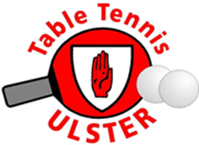

**ULSTER CLOSED CHAMPIONSHIPS 2022 SOUTH LAKE LEISURE CENTRE, CRAIGAVON**

**OPEN SINGLES**



MASTERS SINGLES



U19 OPEN SINGLES



U15 OPEN SINGLES



U13 OPEN SINGLES



**Tournament Regulations:**

* Matches will be played according to the current ITTF rules
* **Each player can only enter maximum of 2 events**
* **Check in from 8.30am on Sunday 13th March 2022**
* We will need to finish the tournament at 4.00pm. Therefore, most of the events will be played as best of 3 games at group stage. Matches in 2nddivision, and 1st knock-out rounds will be played as best of 3 games. This is to ensure each player gets the maximum number of matches possible, with the aim of creating an initial Ranking List for both Male and Female competitors.
* Results of this event will be one of the criteria considered in the selection of the Ulster Squad for the Interprovincial Championship to be held in April
* Prizes/Awards will be presented to both Male and Female winners and runners-up in each event

**Please note some changes to the start times for U19, U15 and U13 events**.

**EVENT START TIME**

OPEN SINGLES 9.00AM

MASTERS SINGLES 12.00 NOON

U19 OPEN SINGLES 12.00 NOON

U15 OPEN SINGLES 1.15 PM

U13 OPEN SINGLES 1.15 PM