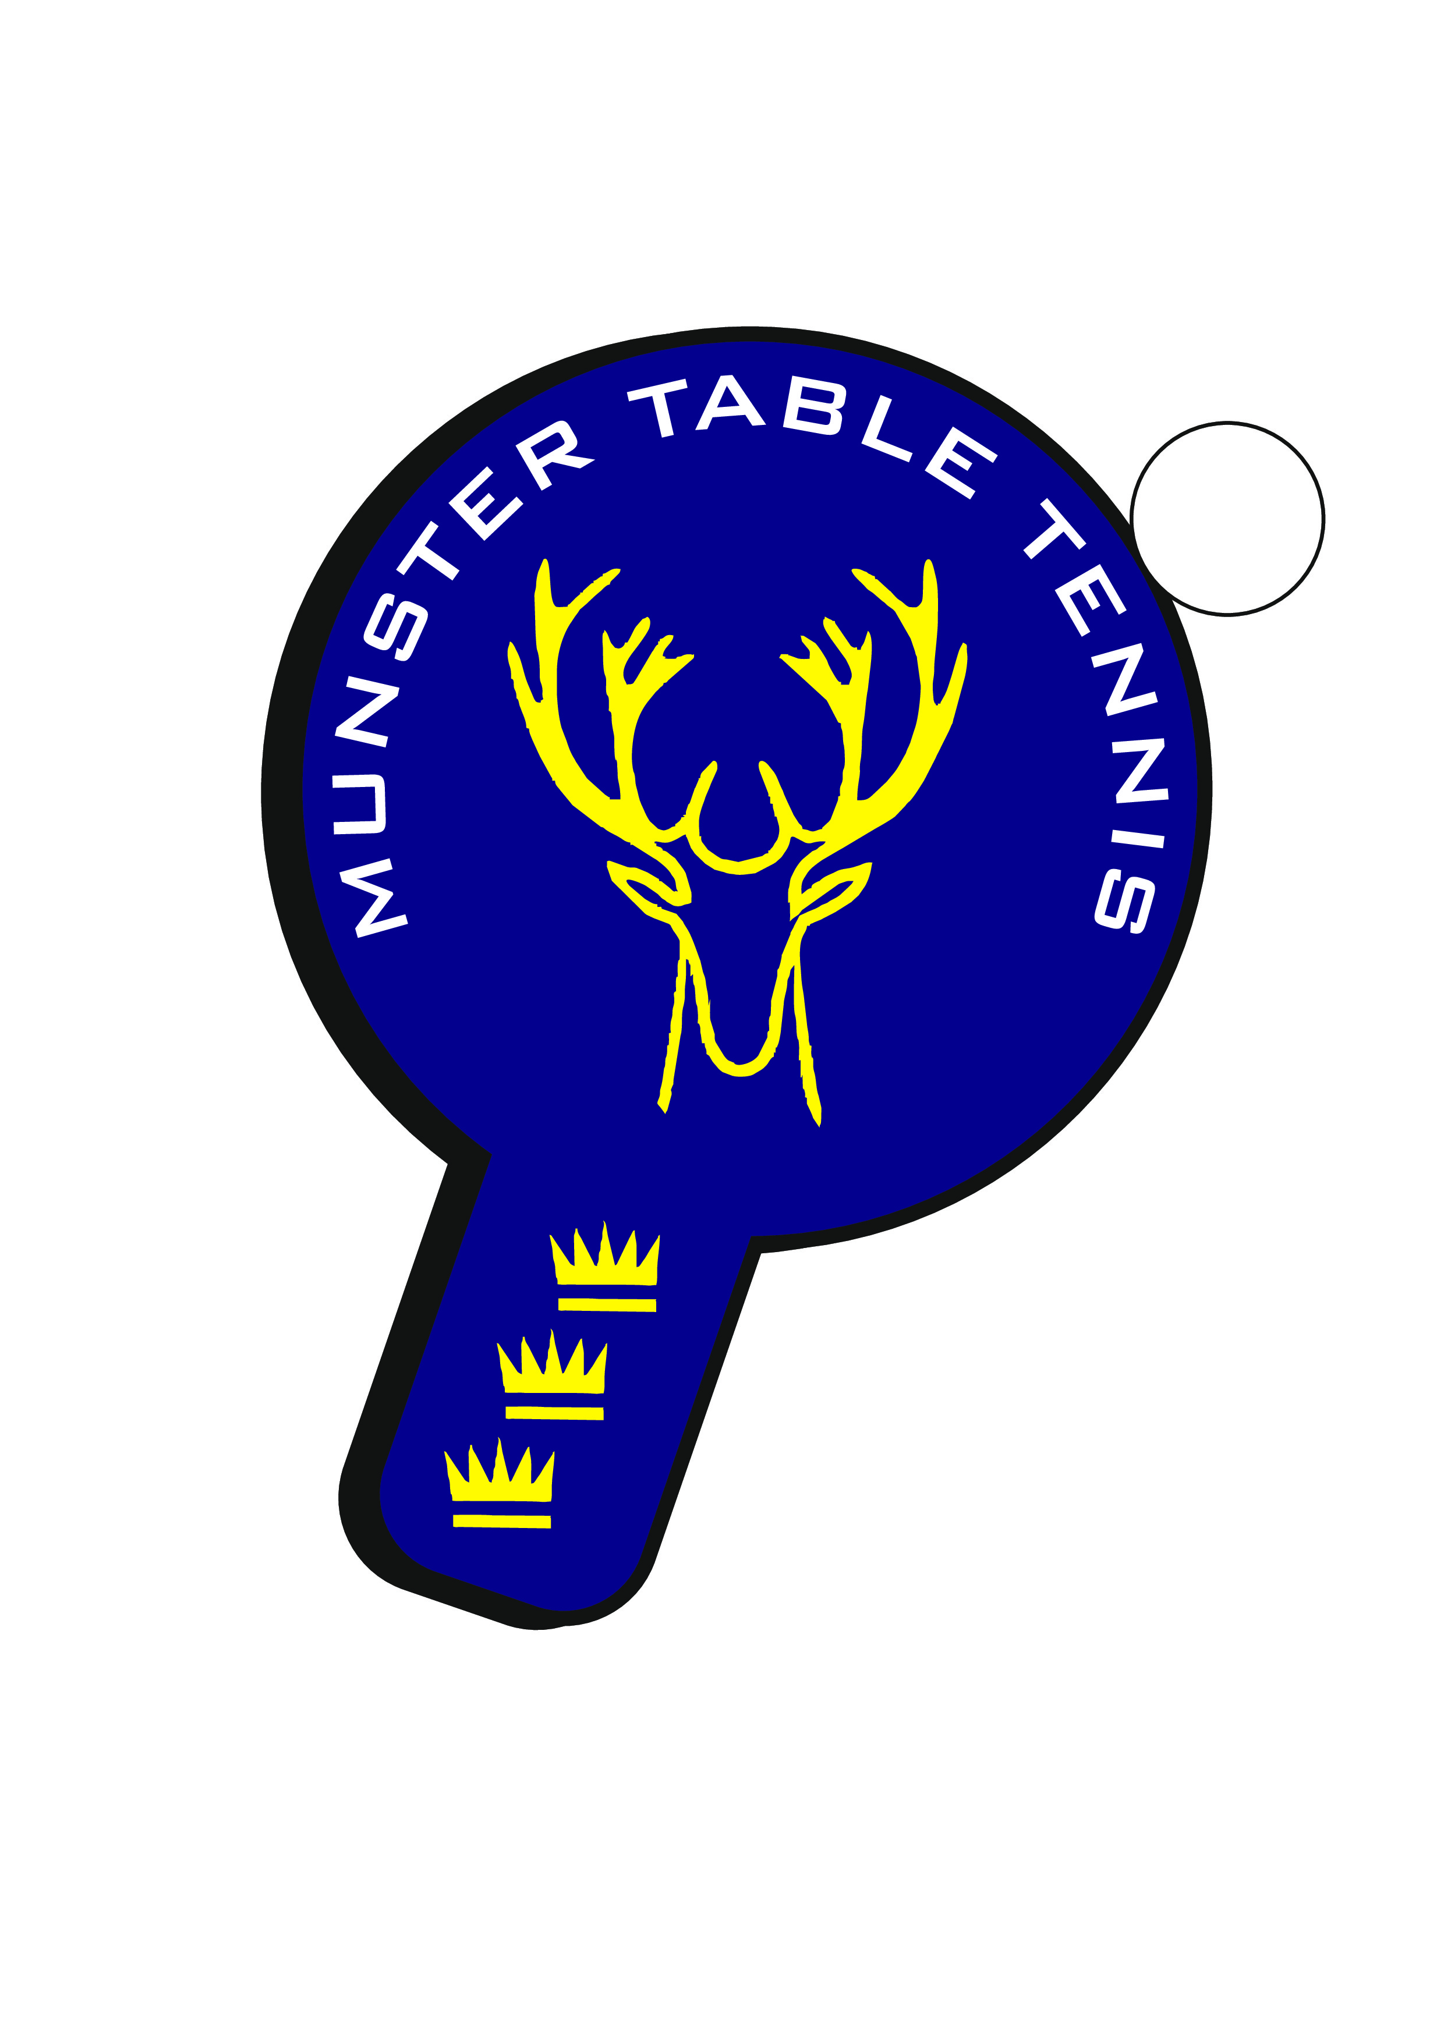
Munster Grand Prix 30 January - Results (in order)
Grand Final
Winner: Philip Shaw
Runner Up: Michael Lotiskie
Semi Finalist: Conor O’Callaghan
Semi Finalist: Sean Loughnane
Division 1A
Philip Shaw
Conor O’Sullivan
Ben Loughnane
Rory O’Brien
Matthew Collins
Division 1B
Michael Lotiskie
Sean Loughnane
Conor O’Callaghan
Rory Griffin
Nikolai Genov
Alessandra Fadda
Division 2A
Megan O’Brien
Adam Ryle
John O’Sullivan
Jack Healy
Brian Plunkett
Division 2B
Attila Senior
Margie Hadden
Luke Owens
Liam Murphy
John Barry
Caoimhe Deane
Division 3A
Alex Healy
Darragh Crowley
Ben Cahill
Rian Bolton
Alex Scott
Division 3B
Sean Buckley
Adrian Starke
Angelica O’Shea
Kian Murphy
Evan Naughton
Ryan Kennedy-Morley
Division 4A
Lucy Lou O’Brien
Jack O’Brien
Lee Barton
Daniel Klymemko
Matthew Gibson
Cooper Haskett
Division 4B
Ethan O’Sullivan
Florian Lotiskie
Attila
Humman Heba
Lynn Harnett
Jacob Haskett
Division 5A
Darragh Ruddy
Nicholas O’Brien
Aoife Kelly
David Horgan
Paul Fitzgerald
Patricia Groarke

