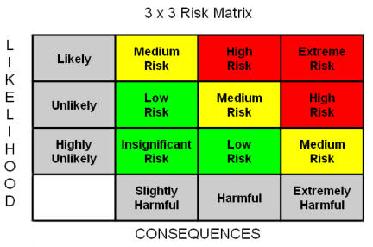

The risk matrix above should be used to estimate the overall risk to a child or young person. Firstly think about the likelihood of the risk from occurring, is it likely to happen, unlikely or highly unlikely. This is on the left hand side of the table. Then think about the consequences if the risk were to occur, would it be slightly harmful, harmful or extremely harmful. This is on the bottom of the table. Connect the two to come to an overall risk factor. For example if I am assessing the risk of physical harm such as an infection in a venue that has no washing facilities I might think that it is likely that a child may get sick, and the consequences of this may be harmful. Joining up these two scores I end up with a highly risky situation. However I could mitigate the risk to some extent by bringing handwash and cleansing gels and encouraging the children to use these.

Club _______________________ Activity_______________________ Location _____________________ Date______
Risk – Identify the elements of the activity/event are hazardous | Who is at risk? | Risk Factor  = the likelihood that the risk will happen x the consequences if it does. High Medium or Low Risk | What controls can be put into place to ensure that the risk does not result in an accident or an injury?
Consider:  - Facilities  - Equipment  - Participants  - Inappropriate Behaviour  - Risk of fire  - Photography  - Changing facilities | Consider:  - Child or young person  - Coach  - Officials  - Spectators | Consider the risk matrix on the first page | List the precautions that can be taken in order to minimise the likelihood of the risk occurring

Form Completed by: Position: Date:

