
CLUB AFFILIATION & STANDARDS PROGRAMME
2026/2027 Season

Every club starts at Bronze — a low-barrier, affordable entry point that gets you affiliated, insured, and part of the Table Tennis Ireland community. As your club grows, Silver and Gold (in due course) offer a clear, supported pathway to becoming an attractive and well-governed club.
Our commitment to every member
Table Tennis Ireland holds all affiliated clubs to a clear standard of compliance — regardless of club size or type. These standards exist to protect your members, your coaches, your volunteers, and your club.
A club that is not fully compliant cannot be fully affiliated — and unaffiliated clubs and members are not covered by Table Tennis Ireland insurance.
Table Tennis Ireland will work with every club to help meet these standards. You are not on your own.
Club Standards Programme — At a Glance
Bronze is the entry point for all clubs and groups — accessible, affordable, and achievable for any new or informal group. Silver builds on that foundation for clubs with a wider membership and greater responsibility. Gold is the aspirational standard for clubs who want to lead the way (that's for the future).
Which tier is right for your club?
Bronze is the entry point for all clubs and groups. Silver applies to clubs with either Junior only or both junior and adult members, or any club with a competitive or developmental focus. Gold is under development and will be confirmed in due course. If you are unsure, contact Table Tennis Ireland and we will help you identify the right starting point.
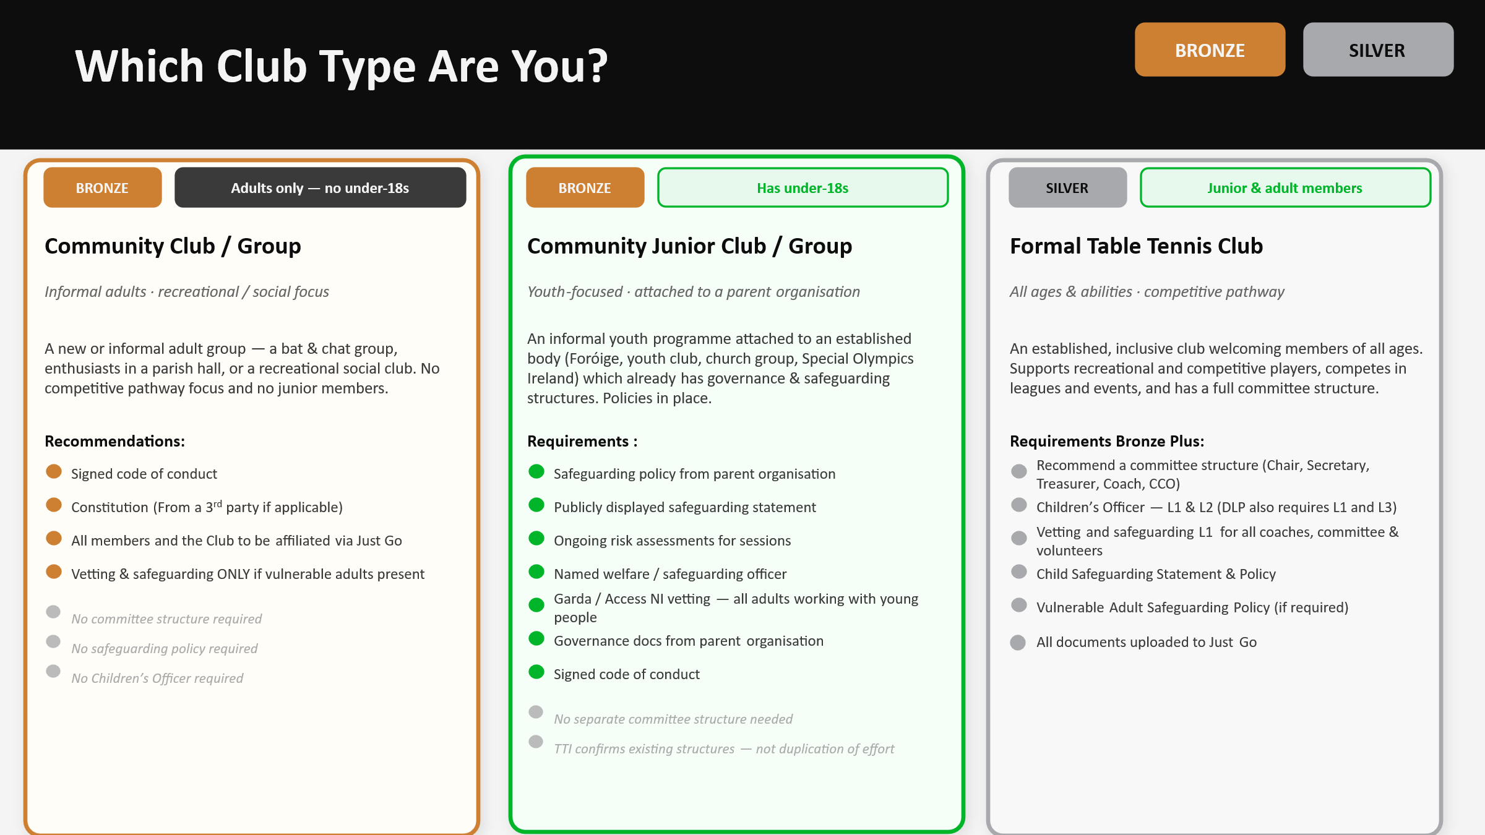
Community Club / Group
What is a community club or group?
A community club or group is a new or informal adult group that has come together around a shared love of table tennis. This could be a bat and chat group, a small group of enthusiasts in a parish hall, or a recreational social club or group. There is no competitive pathway focus and no junior members involved.
We want every community club and group to feel welcome in the Table Tennis Ireland family — whatever their size, wherever they meet, and however long they have been playing. The Bronze standard has been designed with you in mind: straightforward to achieve, low cost, and a genuine foundation for everything that follows.
Bronze standard
The entry point for all community clubs and groups
Why the Bronze standard exists
Even the most informal group needs a shared understanding of how members should treat each other. A code of conduct and a basic governance document are not bureaucratic hurdles — they are what gives your group credibility, protects your members, and ensures your Table Tennis Ireland insurance cover is valid from day one.
If your group includes vulnerable adults, vetting and safeguarding are also required — because the duty of care to those members does not change regardless of how informal your set-up is.

Bronze recommendations — community club / group
These are the minimum requirements for Bronze affiliation. Table Tennis Ireland has templates ready for everything you need.
 | Recommendations
✓ | Signed code of conduct  Agreed to by all members, coaches, and volunteers, and shared with the group. Published on a website or social media where possible. Table Tennis Ireland template available.
✓ | Constitution (best practice but not mandatory)  Your own club constitution (if you have one, or the governing document of your parent organisation (e.g. youth organisation, Special Olympics Ireland). A Table Tennis Ireland template is available in the Club Development Handbook.
✓ | Vetting and safeguarding (if vulnerable adults are members)  Where vulnerable adults participate in your group, all coaches and volunteers in contact with those members must hold up-to-date Garda / Access NI vetting and relevant safeguarding training. Table Tennis Ireland arranges vetting free of charge. You are breaking the law if you have children or vulnerable adults and coaches and volunteers are not vetted.
✓ | All members affiliated  Every participating member must hold a valid Table Tennis Ireland membership via Just Go. Unaffiliated members and clubs are not covered by Table Tennis Ireland insurance.
What Bronze gives your club or group
Full insurance cover  Public liability, employer's liability, and personal accident cover for all affiliated members at no extra cost. | Free Access to the Just Go Database and TT League app  Manage sessions and members digitally through the Just Go platform and register to play leagues on the league app.
Club Development Handbook  Access to Table Tennis Ireland governance templates, safeguarding guides, and practical resources. | Grant access  Eligible for local council or sports partnership grants, Community Sport Facilities Fund (ROI), and local sports partnership funding alerts.
Table Tennis Ireland support  Direct access to Table Tennis Ireland Club Development Officers for advice, guidance, and practical help. | National recognition  Your club or group listed on the Table Tennis Ireland website and recognised as part of the national table tennis community.
Ready to grow? The path to Silver is closer than you think.
Once your club or group has its Bronze foundations in place, Silver is a natural next step when your membership grows or your ambitions do. Table Tennis Ireland will support you at every stage of that journey.
KEY DATES
1 August 2026  Affiliation opens | 31 October 2026  Document upload deadline | 30 November 2026  Final compliance deadline

To begin your affiliation, log in to Just Go. New to the process? Fill in the Table Tennis Ireland setup form and we will get you up and running quickly.
New Club Registration Form — Click Here
Questions? Email membership@tabletennisireland.ie or request a call back.

Community Junior Club / Group
What is a community junior club or group?
A community junior club or group is an informal youth table tennis club or group — a bat and chat type programme for young people — that is attached to an already established organisation such as a church group, Foróige, a youth club, or Special Olympics Ireland. That parent organisation already holds appropriate safeguarding, governance, and welfare structures. The club or group is seeking Table Tennis Ireland affiliation to formalise their table tennis activity, not to build new structures from scratch.

We recognise that many community junior clubs and groups already operate to an excellent standard through their parent organisation. Table Tennis Ireland affiliation should feel like a natural addition to what you are already doing — not a duplication of effort.
Bronze standard
The entry point for community junior clubs and groups
Why Table Tennis Ireland confirms your existing structures
Young people deserve the highest standard of protection. Before Table Tennis Ireland can accept your existing structures as sufficient for Bronze affiliation, we need to confirm they meet our requirements. This is a straightforward process — not a barrier — and in most cases a quick conversation is all it takes.
Contact Table Tennis Ireland before starting your affiliation and we will confirm what applies to your club or group.
What Table Tennis Ireland will confirm is already in place — Bronze checklist
Submit copies of the following with your affiliation application or contact Table Tennis Ireland to discuss before you begin.
 | Requirement
✓ | Safeguarding policy  A current, signed safeguarding policy from your parent organisation that covers the young people in your group.
✓ | Safeguarding statement  A safeguarding statement that is publicly displayed — on a website, noticeboard, or communicated to members and families.
✓ | Risk assessment  A current risk assessment covering your table tennis sessions and the environment in which they take place.
✓ | Named welfare / safeguarding officer  A named, appointed individual responsible for safeguarding within your group, with appropriate training for that role. Don't worry we can help with this if its new.
✓ | Garda / Access NI vetting  Evidence that all adults working with young people are fully vetted. Table Tennis Ireland arranges any outstanding vetting free of charge.
✓ | Governance documents  A constitution or equivalent governance document from your parent organisation that covers the operation of your group.
✓ | Signed code of conduct  A code of conduct adopted and signed by coaches, volunteers, parents/carers, and players — either Table Tennis Ireland's own or your parent organisation's equivalent.
Not sure whether your existing documents meet Table Tennis Ireland's requirements?
Contact us before you start your affiliation. Email membership@tabletennisireland.ie or request a call back and we will review your documentation with you directly. In most cases this is a straightforward conversation — whether you are a club or a group.
Thinking about growing into a full table tennis club? Silver is your next step.
If your junior group develops its own independent structure — with its own officers, committee, and growing membership — Silver affiliation as a more formal table tennis club may be the right move. Table Tennis Ireland will support that transition every step of the way.
KEY DATES
1 August 2026  Affiliation opens | 31 October 2026  Document upload deadline | 30 November 2026  Final compliance deadline

Get in touch with Table Tennis Ireland before you begin so we can confirm your existing structures are sufficient.
New Club Registration Form — Click Here
Questions? Email membership@tabletennisireland.ie or request a call back.

Formal Table Tennis Club
What is a formal table tennis club?
A formal table tennis club is an established, inclusive club that welcomes members of all ages and abilities. It supports both recreational and competitive players, offers a structured development and playing pathway, and competes regularly in leagues and events. The club has junior and adult members and operates with a full committee structure.
Formal table tennis clubs are the backbone of table tennis in Ireland. The Silver standard reflects that — it sets a clear, comprehensive bar that protects your members and signals to your community that your club is somewhere worth being.
Silver standard
The standard for formal clubs with junior and adult members
Why your standards set the tone for the whole sport
The young players and adults who walk through your doors are trusting your club — and their families are trusting you — to provide a safe, well-governed, and inspiring environment. The Silver standard is comprehensive because your responsibility is comprehensive.
A club that cannot demonstrate Silver standards cannot be fully affiliated with Table Tennis Ireland. This is not a line we move — but we will work with every club to help them get there and maintain those standards year on year.
Table Tennis Ireland provides free vetting, access to safeguarding courses, governance templates, and direct support from Club Development Officers. You do not have to do this alone.
Silver requirements — formal table tennis club
Every formal table tennis club must have all of the following in place before Silver affiliation is complete. These requirements apply to the whole club — junior and adult members alike.
 | Requirements
✓ | Signed code of conduct  For coaches, volunteers, parents/carers, and players. Signed — not simply circulated — and published on your club website or social media.
✓ | Signed club constitution  A template is available in the Table Tennis Ireland Club Development Handbook.
✓ | Child Safeguarding Statement and Policy  Reviewed, signed, uploaded to Just Go, and displayed prominently on your website and social media.
✓ | Adult Safeguarding Policy (if required)  Reviewed, signed, and displayed prominently online.
✓ | Children's Safeguarding / Protection Officer (CCO)  Appointed, fully vetted, and holding Safeguarding Level 1 and Level 2. May also serve as Designated Liaison Person (DLP); the DLP role additionally requires Level 3.
✓ | Vetting — all coaches, committee members, and volunteers  All those in contact with junior members must hold up-to-date Garda / Access NI vetting and Safeguarding Level 1. All vetting is free through Table Tennis Ireland. It is best practice to vet committee members but at the very least all committee members of the club should complete a safeguarding level 1 course.
✓ | A committee structure in place  Chairperson, Secretary, Treasurer, Lead Coach, and Children's Officer as required by the club. All officers should hold a generic club email address.
✓ | All members affiliated  Every participating member must hold a valid Table Tennis Ireland membership via Just Go. Unaffiliated members are not covered by Table Tennis Ireland insurance.
✓ | All documents uploaded to Just Go  By 31 October 2026. Final compliance deadline is 30 November 2026.
What Silver gives your club
Full insurance cover  Public liability (€6.5m), employer's liability (€13m), professional indemnity, and personal accident cover at no extra cost. | Free Garda / Access NI vetting  Complimentary vetting for all coaches and volunteers working with young people.
Safeguarding training  Level 1 and 2 courses throughout the year. Silver clubs get priority access to all courses and CPD. | Competitive pathway  Players can enter Table Tennis Ireland leagues, ranking events, classification events, and national competitions.
Grant support  Eligible for local council or sports partnership grants, Community Sport Facilities Fund, and local sports partnership funding alerts and hands-on support with grant applications. | Inclusion programmes  Silver clubs are eligible to participate in Table Tennis Ireland's Inclusion programmes e.g. Disability, Women in Sport etc.

Log in to Just Go to begin your affiliation. If you have questions about any compliance requirements, reach out and Table Tennis Ireland will guide you through every step personally.
New Club Registration Form — Click Here
Questions? Email membership@tabletennisireland.ie or request a call back.
Not sure which category or tier fits your club? Some clubs span more than one type or have membership that changes from season to season. Contact Table Tennis Ireland and we will help you work out exactly what applies. Email membership@tabletennisireland.ie or request a call back.

